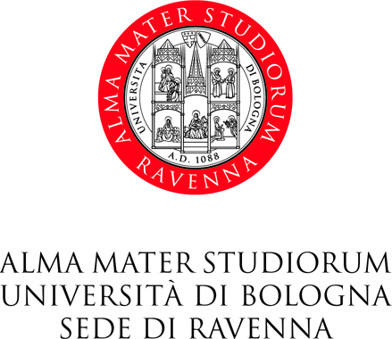

Master Degree Course in Science for the Conservation-Restoration of Cultural Heritage

(LM S.Co.Re.)

Thesis title

Candidate for S.Co.Re final dissertation: _______________________________________________
^{(name )} ^{(surname)}
born in ____________________________________ on ___________________
University registration number (matricola): _______________________
Thesis Supervisor: Professor ___________________________________

Name of the S.Co.Re teaching activity held by the supervisor ____________ ___________________________

Master degree thesis title¹
_________________________________________________________________________________________
_________________________________________________________________________________________
_________________________________________________________________________________________

¹The thesis title cannot be modified after the approval of the S.Co.Re. Committee.

Ravenna, ______________________

The Co-supervisor The Supervisor
______________________________ ______________________________

In compliance with the Italian Law 196/2003 (Personal data protection code), personal data will be processed exclusively for the institutional purposes of the University of Bologna.

